Challenges & Opportunities of Cyber Security

S.O.U.L. (Skills Onto Uplifting Lives), Community Service Cell, DEC S.O.U.L. (Skills Onto Uplifting Lives), Community Service Cell, of Department of Electronics and Communication Engineering conducted a expert talk on Challenges & Opportunities of Cyber Security for S8 ECE and CSE students by Ms. Babitha B. P., Chief Information Security Officer, CSB Bank, Member of ISACA, Kochi Chapter. The expert talk was planned to introduce career opportunities available cyber security field for S8 ECE and CSE students. The event was conducted on April 23rd 2021 in CISCO webex online platform.
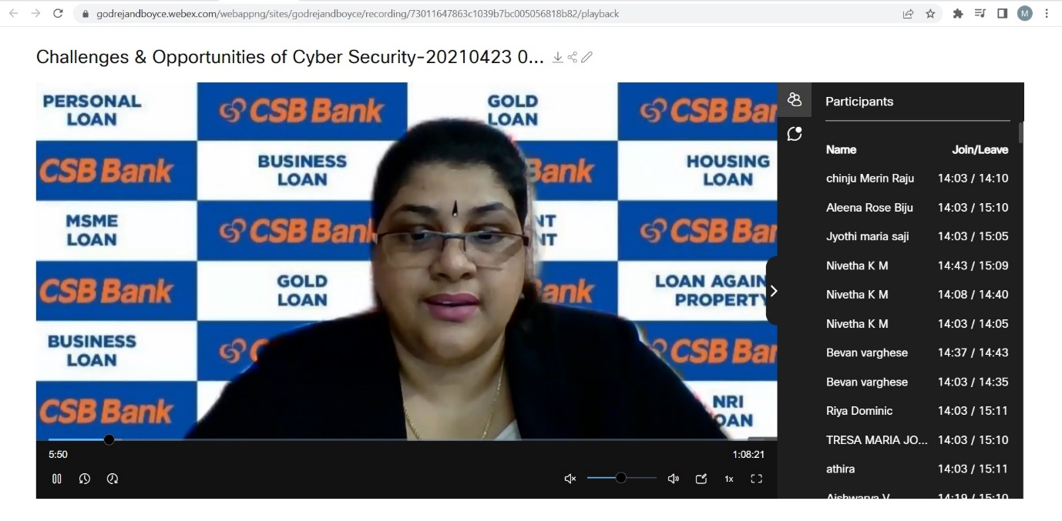
Ms. Babitha B. P. was the resource person. The event was hosted by Ms. Rinju Mariam Rolly under the coordination of Dr. Jaison Jacob. Around 80 students attended the talk. The speaker explained the need of cyber security and job opportunities in cyber security field. She also explained about ethical hacking and importance of keeping data secure. After the talk, the speaker had a question answer session to clear the doubts of students and addressed their enquiries. The session concluded by taking the feedback from stakeholders.

