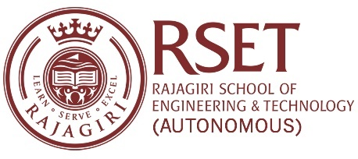
N O T I C E
Notice No: RSET/PR/N/7831 Date: 23-Mar-2024

The Literary Events for Bharatham-2024 will be conducted on 27th March, 1st, 2nd & 3rd April as per the following schedule.
Date and Time | Events | Faculty in-charge
March 27, 2024  Wednesday  3:15 PM - 4:15 PM | Short Story (English) | Dr. Elizabeth Rita Samuel (DEE)
 |  | Ms. Kiran Jayan (DBSH)
 | Poetry Writing (Malayalam) | Ms. Kuttyamma A J (DIT)
 |  | Dr. Ragin Ramdas (DBSH)
 | Essay Writing (Hindi) | Mr. Sandy Joseph (DCS)
 |  | Ms. Jasmin Sebastian (DEC)
 | Pencil Drawing | Mr. Akash James (DME)
 |  | Ms. Aparna Sanjay (DMA)
April 1, 2024, Monday 3:15 PM - 4:15 PM | Short Story (Malayalam) | Ms. Arya M V (DMA)
 |  | Ms. Mehbooba P Shareef (DCS)
 | Poetry Writing (Hindi) | Ms. Sangeetha Jamal (DCS)  Mr. Krishnaraj P P (DME)
 | Essay Writing (English) | Dr. Rinku Jacob (DBSH)
 |  | Ms. Kiran Jayan (DBSH)
 | Movie Poster Designing | Mr. Sujith S (DBSH)
 |  | Mr. John Paul C D (DME)
April 2, 2024 Tuesday 3:15 PM - 4:15 PM | Short Story (Hindi) | Ms. Saritha V (DBSH)
 |  | Ms. Deepthy G S (DEC)
 | Poetry Writing (English) | Mr. Rajeesh Rajkumar (DBSH)
 |  | Dr. Ragin Ramdas (DBSH)
 | Essay Writing (Malayalam) | Dr. Ramkumar P B (DMA)
 |  | Ms. Anu Maria Joykutty (DCS)
 | Caricature | Ms. Harsha A. (DEC)
 |  | Dr. Athul Sathyanath (DME)
April 3, 2024, Wednesday 3:15 PM - 4:15 PM | Travelogue | Mr. Rajeesh Rajkumar (DBSH)
 |  | Dr. Rejeesh T Chacko (DBSH)
 | Meme Making | Mr. Vinay Menon (DBSH)
 |  | Mr. Krishna Das Naduvath (DIT)
 | Comic Strip | Mr. Vinay Menon (DBSH)
 |  | Dr. Athul Sathyanath (DME)
 | Collage | Ms. Liza Annie Joseph (DAE)  Ms. Anila Kuriakose (DEC)
PRINCIPAL

