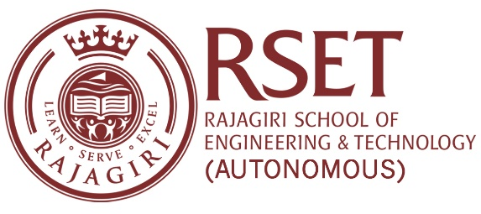

**N O T I C E**

**Notice No:  RSET/PR/N/7493  
Date:**27-Oct-2023

**RESEARCH SEMINAR IN MATHEMATICS**

**30th in the series**

As a part of the ongoing seminar series, Ms. Cinderella T J, Research Scholar, RSET, will give a talk on "On the space of Homeomorphisms and Effro’s Theorem" on Saturday, **Venue: LH 6, Main Building**  
28 October 2023.

**Time: 11:00 am – 12:00 pm**

All interested are welcome to attend.

Principal