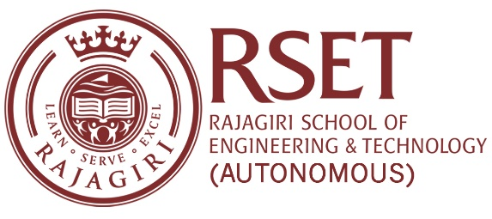

**N O T I C E**

**Notice No:  RSET/PR/N/7486  
Date:**19-Oct-2023

**Dept. of Artificial Intelligence & Data Science**

In association with

**Industry Institute Interaction Cell**

Organizes a Distinguished Lecture on  **Generative AI: Insights, Applications & Tools**

by **Mr. MAHALINGAM P R**, **Center Head (Kochi** ) & Manager, Sales, InApp Information Technologies Pvt. Ltd., Kochi.

**Date: 26 October 2023**

**Time: 3.00 pm- 4:30 pm**

**Venue: Multimedia Hall**

powered by

**Articon - Association of AI & DS and Industry Institute Interaction Cell**

PRINCIPAL