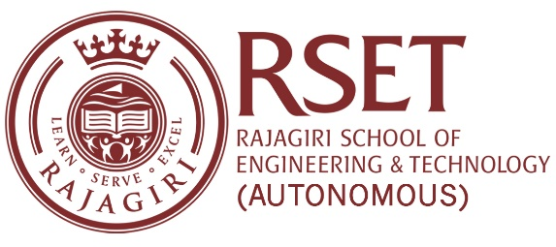

**N O T I C E**

**Notice No:  RSET/PR/N/7427  
Date:**23-Sep-2023

NSS RSET, under the Swachh Bharat Mission, is conducting a cleanliness drive at Ernakulam South and Ernakulam North Railway Station on Saturday, 23rd September 2023, and Govt. L P School Vypeen on Sunday, 24th September, 2023.

Principal