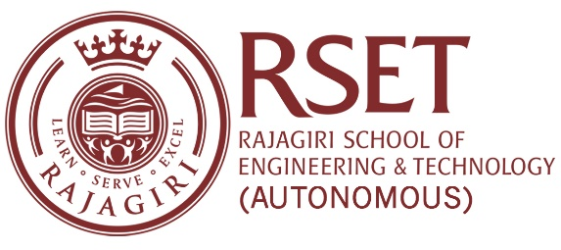

**N O T I C E**

**Notice No:  RSET/PR/N/7455  
Date:**05-Oct-2023

**ACRESERVE - ISHRAE RSET Chapter**

The Department of Mechanical Engineering in association with The Indian Society of Heating, Refrigerating and Air Conditioning Engineers (ISHRAE) is organizing ACRESERVE 2023-2024 on 6th October 2023 at Gallery Hall from 1:30 pm to 4:30 pm. All are cordially invited.

 It is a program conducted across India by various ISHRAE chapters exclusively for technical professionals, college students, service technicians, service executives, and solution providers to know the latest trends in the service of HVAC equipment.

**The theme of ACRESERVE 2023-2024: - “**Enhancing Competencies of HVAC&R Service Professionals**”**

**Faculty Coordinators:**Mr.P.P.Krishnaraj, Asst. Prof of Mechanical Engineering Department, RSET.

PRINCIPAL