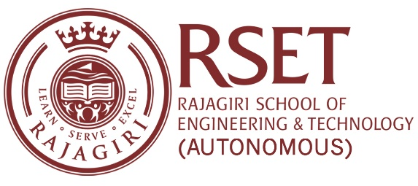

**N O T I C E**

**Notice No:  RSET/PR/N/7298  
Date:**27-Jul-2023

**RESEARCH SEMINAR IN MATHEMATICS**

**29th in the series**

As a part of the ongoing seminar series, Ms. Bindu V A, Assistant Professor, RSET, will give a talk on “Exponential Diophantine Equation in two variables" on Saturday, 29th July 2023.

Venue: LH 6, Main Building

Time: 11:00 am – 12:00 pm

All interested are welcome to attend.

Principal