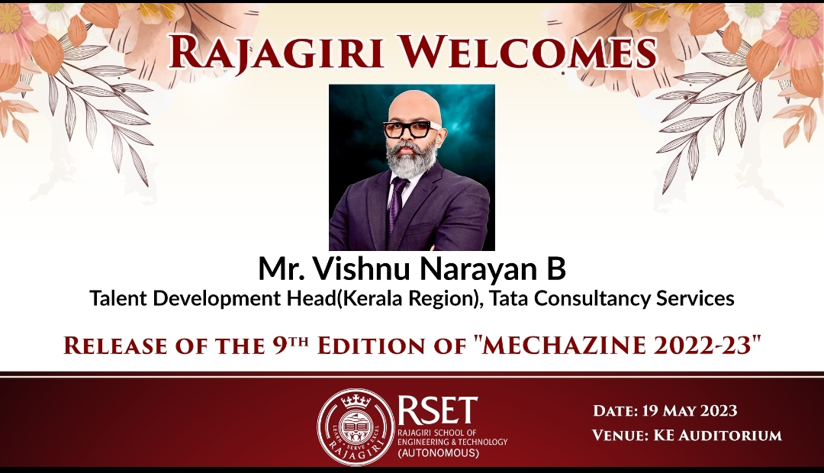

Vishnu Narayan is very passionate about Training, Mentoring and Coaching. He started his career as a Mechanical Engineer and then shortly moved to IT Industry. He was the Plant Engineer for VKL Industries and in IT sector worked for Cognizant, Research Machines and UST Global in various Technical and Leadership roles. He joined TCS 6 years back as a Delivery Leader. His key achievement was when his prestigious project was presented in front of Tata Chairman (Ratan Tata) for its unique value proposition. Being Agile his forte, he then soon moved to Agile Ninja Coach role proactively taking up transformational responsibilities for multiple accounts. He helped close to 500 Associates to embrace agile through workshops and MVP creations. He is a Gold Certified Mentor for TCS and loves to create positive impacts. Now enjoying his responsibilities with Talent Development for Kerala Region.

He is a fitness enthusiast and utilize time as YouTuber, Blogging, Cook and an Actor on his leisure. Happily married and blessed with 2 male cubs.